# TOPIC: GESTURE CONTROLLED ROBOTIC CAR

# Author: EZEONYEDIKA AUDREY OGONNA. R

# PROJECT DESCRIPTION

**INTRODUCTION**

Fundamentally, this project is a robot that moves based on hand gestures. This project aims to build a hand gesture-controlled robot that can be used in hospitals, shops, hotels, homes, etc., where contact-less delivery is necessary.

**OVERVIEW**

This project essentially consists of two parts, the transmission and receiver section. The transmission section is placed on the hand and the reception section which is the car. This robot can be used for contactless delivery and easier movement for disabled persons. The gestures made by the hand can be converted into electrical signals by lines of code and with the aid of an Inertial Measurement Unit (IMU)[MPU9250] accelerometer and gyroscope sensor.

The microprocessor processes incoming signals from the IMU and sends them to the Radio Frequency Transmitter on the transmitting side, while on the receiving side these signals are received by an identical Radio Frequency Receiver and then to the Arduino (receiver) for decoding. After decoding, the Arduino (receiver) sends signals to the motors through the L298N Driver to actuate the motor driver.

**COMPONENTS USED**

let's begin with the components used

|  |  |
| --- | --- |
| Components and Supplies | Quantity |
| Arduino UNO | 2 |
| DC Geared Motor | 2 |
| 4.2v Lithium-Ion Battery | 4 |
| Inertial Measurement Unit (IMU) [MPU9250] | 1 |
| Switch Actuator | 3 |
| Robot Wheels | 2 |
| Robot Chassis | 1 |
| RF Transmitter and Receiver (nRF24L01) | 2 |
| Gloves | 1 |
| Battery holders | 2 |
| L298N Motor Driver | 1 |

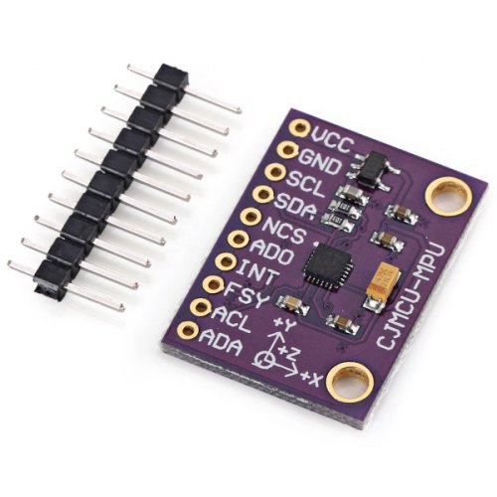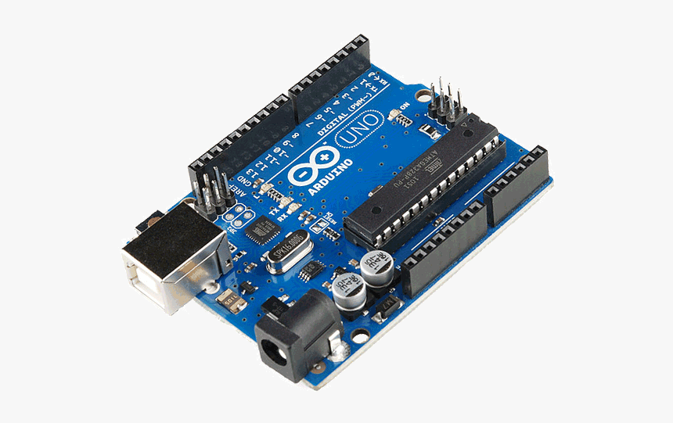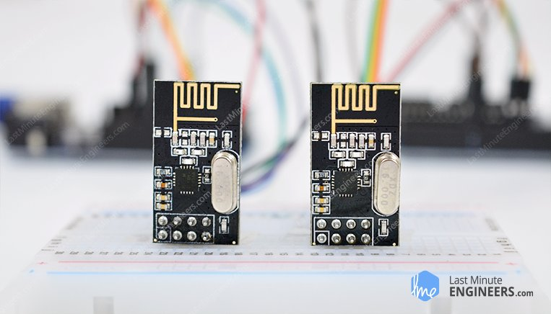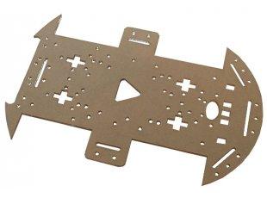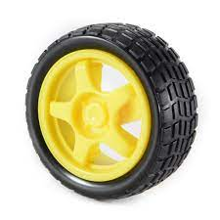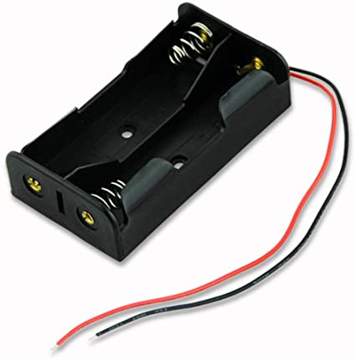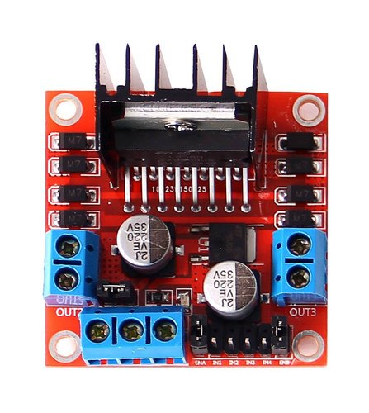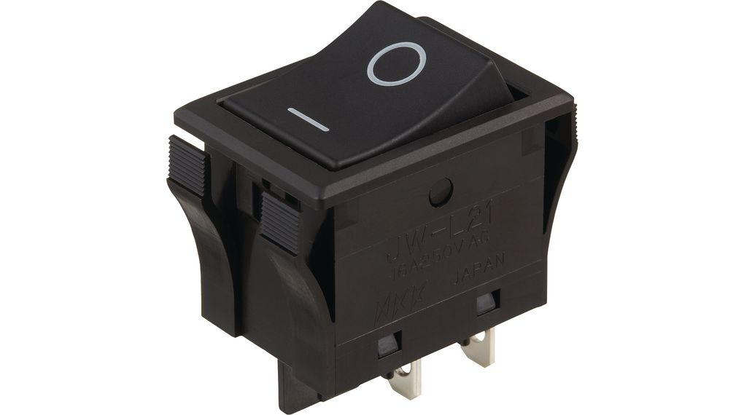

Inertial Measurement Unit (IMU) [MPU9250]

**EQUIPMENT USED:**

* Soldering iron
* Soldering lead
* Hot wax gun
* Wax glue

# Transmission Circuit

The components used in the Transmission circuit are MPU 9250 sensor, Arduino UNO, nRF24L01, Lithium-Ion batteries, Push-to-make switch, Rocker switch, LED, Resistors, Wires. The circuit is powered by two Lithium-ion batteries connected in series. The MPU 9250 must have 5V power supply. The switch and led were connected so that the transmitted

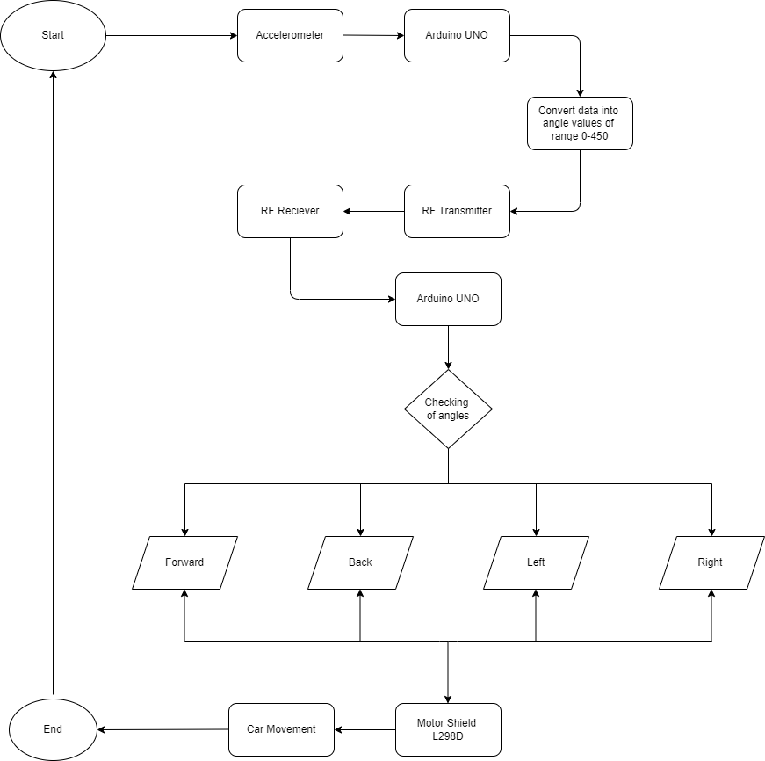

RECEIVER CIRCUIT

This side of the project was built using an Arduino Uno, a rocker switch, an L298N motor driver, Lithium-Ion batteries, DC Geared Motors, robot chassis, robot wheels with nuts, and bolts to secure the components fastly to the robot chassis.

Building the robot

Both sides of the robots should be built using the circuit diagrams attached to the word document.

After building the transmitter and receiver circuit the codes should be uploaded to the microcontrollers and reset.

CONCLUSION

Before uploading the code the libraries should be properly installed, as installing the libraries posed the biggest challenges during the course of the project.